Truth’s Breath of Stress Air Website and its Persuasive Power

Abigail Souders
James Madison University
SCOM 381: Rhetorical Research
Dr. Matt Brigham
12.11.24

Abstract
This paper aims to understand the rhetorical aspects of the Truth Initiative Breath of Stress Air interactive website. The goal of this website is to persuade the younger generation to think about the stressful effects of their vaping habits, and hopefully encourage them to join their text-in program that supports quitting vaping. This analysis explores previous rhetorical criticism of anti-smoking campaigns, along with understanding how powerful identification can be to an audience, and it will explore previous rhetorical criticism on websites and the possible power it can hold. Website design is one of the more important aspects of this campaign since it implements an edgy, bright art style and interactive features that is not only supposed to teach people about the dangers of vaping, but is also used to connect to a younger generation and hopefully guide them in the right direction. In order to fully understand how the Truth Initiative is effective in this approach, this paper will utilize the design rhetoric method on the site's creative endeavors and design aspects. By using the theory of design rhetoric this paper will be looking at the interactive aspects of the site, the artwork/style, word choice, and overall “aesthetic” in how it appeals to a younger audience.
Introduction
You take in a deep inhale of smoke, hold it in, then exhale it all out in the same breath. Within seconds you should be relaxed with your mind at ease, because vaping is supposed to help calm you down, right? That's the type of rhetoric that has been spread around like a puff of smoke all throughout high schoolers and young adults, getting vapes into the youngest generations’ hands. Although there seems to be more PSAs out there than ever about the dangers of nicotine and smoking, kids are still getting caught in the tobacco industries web and becoming re-addicted to smoking. The Truth Initiative has noticed this problem and has tried many ways to convince the younger generation that the vaping epidemic can come to an end. One of their most recent campaigns is an interactive website that is weaved in their campaign Breath of Stress Air. This site is meant to inform people about the stress and negative mental health effects vaping can create for a person. This site is one long page and is filled with popping colors and imagery, along with various facts about the stressful effects of smoking along with interactable features where users can click and play with. The Truth Initiative has done many campaigns in the past that involve connecting to a younger audience, and with the ever growing internet at the tip of our fingers this site aims to connect to the younger generation, who were molded by the internet, to inform them about the stress vaping can cause. However, the question is: How much persuasive power does this site hold in order to gain traction for their audience and convince them about the dangers of vaping?
In my analysis of the Truth Initiative Breath of Stress Air interactive website I aim to discover how this site holds persuasive power for a younger generation. Because there is an increase of web-based media, there needs to be an analysis on how this type of content, whether it be on a social media platform or a webpage, can be made in a way that could hold any persuasive power over an audience. The Truth is a notable brand amongst the youth and has aimed to stop kids from vaping for years, so it is important to understand how their web-based content is conceived in a manner that is able to convince a child to stop smoking, and whether or not the design aspects, interactivity, and visual elements is enough to do that task. This paper goes over previous research on anti-smoking campaigns, identification, and websites to see what previous studies have concluded what has been working, and what has not. I will also go over how the digital rhetoric method can play a role in persuading an audience, and will see if Truth’s website fits into this method, and how effective their design elements actually are.
Context
According to the Mayo Clinic they state that the Truth Initiative is a public health organization dedicated to spreading the word about the dangers and negative effects of tobacco use, with their overall goal to free the world of these harmful habits (Dueffert, n.d.). They are especially concerned about the younger generation and nicotine addiction, creating various programs aimed to connect to young adults to help them quit smoking. In their 20 years of service, they have helped decline smoking from 23% in 2000 to an amazing low of 3.7% in 2019 (Dueffert, n.d.). However, among middle and high schoolers, it is reported in 2024 that nearly 40% of kids report that they are smoking, and many show signs of a serious nicotine addiction (Targeted News Source, 2024). Vaping or vaping devices are electronic devices used to deliver aerosol products into the body by inhaling its smoke content (NIDA, 2020). Vaping has been around for decades, but with these new age vaping devices more people are finding them, especially young teens. According to the FDAs annual report of nicotine use for 2024, they state that 5.9% of middle and high schoolers use disposable e-cigarettes with popular brands such as an Elf bar, VUSE, and much more. With this enormous amount of vapers, it requires the Truth Initiative to kick in their gears and prevent Gen Z from further harm.
In the early 2000s the Truth Initiative kick-started their campaign ads nationwide (truth initiative, n.d, Our History). Their brand is meant to connect with the youth of America, and tries to capture their attention by using provocative videos and creative means on websites and ads. Their main goal with using these campaigns is to spread awareness about nicotine and the truth behind the big tobacco companies (truth initiative n.d., Youth Smoking and Vaping Prevention). With this, they are also known to provide resources for young adults to help them quit smoking. This includes the administration of online tools that can connect to young viewers and give them evidence-based ideas on how to quit, with their first being BecomeAnEx in 2008. 2014 was almost the end of the vaping epidemic, due to the amazing statistic that proved that only 10% of High schoolers smoked compared to the 23% in the early 2000s (PR Newswire USA, 2014). Now, that statistic has risen yet again to 23% (FDA, 2024). With this, new campaigns have been created to help kids stop vaping, including text-in programs and interactive sites (truth initiative, n.d., Our history). That includes the Truth Initiatives newest campaign A Breath of Stress Air.
Due to the success of the Truth Initiatives It's Messing with Our Heads: Depression Stick campaign, which was the first to connect mental health issues with vaping, a newer campaign that focuses on anxiety and stress levels was put in place. In a collaboration with New York based Mojo supermarket this campaign is supposed to spread awareness on how vaping is not good for stress levels and how it causes anxiety instead of lessening it (US Staff 2022). It is also supposed to spread awareness on the myth that vaping nicotine is a stress reliever, and also attacks tobacco companies for promoting this rhetoric and false claims. In fact, in support of the Truth campaign, Surgeon General Vivek Murthy issued an advisory saying that the mental health decline in the youth is an "urgent public health crisis," which goes hand and hand with the youth vaping epidemic (PR Newswire, 2022).
This campaign, like its many predecessors, is created in part to help connect young teens to their text based support program, where they can go and get in contact with somebody who will support them in their journey to quit vaping. Along with this resource, Truth is also in a partnership with Breathwrk that encourages young people to practice breathing techniques to ease their anxiety and hopefully weave them off vaping for good. However, what makes this campaign unique is that they made a new interactive site that is meant to inform younger people the dangers of smoking, and how it is detrimental to not only your health but mental health as well (NCESD, 2023). This site uses bright colors and eye-popping graphics to really catch the attention of teens and young adults, along with research-based information to provide viewers the benefits of quitting, and how to quit. To catch up to the modern times they have also collaborated with Tik Tok influencers and have been promoting this campaign via YouTube and other social media platforms (truth initiative, 2022). The Truth’s Campaigns Breath of Stress Air is supposed to combat the misinformation spreading that vaping is related to relative stress (Buck, 2022). According to Jono Paull, group creative director at Mojo Supermarket who partnered with Truth on this campaign, said that “the biggest misconception we heard from them (Gen Z) was that vaping is a stress reliever, when in fact nicotine increases stress levels. Breath of Stress Air aims to bust that myth by subverting the wellness content Gen Z is actively seeking out each day.” (Corr, 2024).
In order to spread the message, the campaign was first released in two 30 second TV advertisements, and spread across social media (Buck, 2022). They also took over the main website's landing page, implementing an interactive site that features gifs, graphics, popping colors that is supposed to inform viewers about the campaign. The artwork was inspired by modern and retro art styles, relying heavily on emojis, and bright colors, and 90s like artstyle and graphics. They also wanted to make sure the atmosphere felt unique and different without being “out of style” or uninteresting to their younger audience. When scrolling through the site you are met with jumping graphics that are supposed to be imitating “stressful thoughts” along with the site automatically resetting to the top when reaching the bottom. Most of the infographics and information is based on statistics about the effects of vaping on a person's mental health, and also meant to attack tobacco companies and claim they are spreading misinformation. (Campaign, 2022).
The question is now is this campaign effective enough to stop the next generation to follow the same path as our grandparents generation? Can the new Breath of Stress Air website have enough material on it to convince their audience of teenagers to quit vaping?
Literature Review
Anti-smoking campaigns have been around for decades. With that, there are a lot of takeaways and learning opportunities for us to determine what makes a campaign effective, and what does not. Previous research also suggests that different techniques, such as attacking tobacco companies and having relatable characters that represent the smoker can make an impact on its viewers, and can help diminish the number of smokers. Along with learning more from anti-smoking campaigns and its predecessors, learning more about identification and previous research on websites and how that plays a role in persuasion is vital to understand the Truth campaign's newest addition to their anti-smoking rhetoric.
Previous RC on anti-smoking campaigns
Anti-smoking campaigns have been around for a long time fighting against the goliath of tobacco companies, all using different ways of persuasion. An analysis examined one of Truth's most successful campaigns which ran in Florida from 1998 to 2003 (Hoffman, 2016). What they found and what made this campaign unique from previous ones was because they incorporated input from teens and younger people in the whole developmental process. By initiating young teens to help develop a campaign to help their peers stop smoking, many young teens might have a sense of identification to the campaign by relating to the characters on screen which can promote relatability and content comprehension. Another analysis of an anti-smoking campaign in Minnesota was also seen to use teen voices and characters to be in their ads about smoking. This “teen to teen” talk provided a source of credibility for them, as other teens might have their peers on screen and trust in what they are saying (Moore and Reinardy, 2005). The messages in the Florida Truth campaign also implemented an “edgier” style of humor saying that it is “cool to not smoke cigarettes” in order to keep the attention of young adults. These types of humor appeals and identification tactics were used in both campaigns (Hoffman, 2016, Moore and Reinardy, 2005)
In the print ads of Tobacco Free-kids, a rhetorical analysis found that most of the content was aimed at persuading the parents of kids. Their framing was used to encourage adults to contact local legislators to ban smoking for their children's sake. They used shocking imagery as well as credible information to convince their audience that big tobacco companies are persuading vulnerable people, like children, to use their product (Benoit and Harthcock, 1999)
This type of message was also seen in the Minnesota “You Target Me, I’ll Target You.” campaign that was mentioned earlier. One of their main messages was to give information to the youth about tobacco companies and how they are just hungry for money and aim to manipulate a vulnerable audience (Moore and Reinardy, 2005). Language and framing has also been looked at as being important when talking about smoking. In fact, an analysis was done on Russia's rhetoric about smoking and how ineffective they are at talking about the dangers of smoking. In Russia's anti smoking policies messages there is a lot of emphasis on negative framed words than positive framed words, which people usually take as another “authority figure” telling them what to do. Thus, framing words and understanding your audience is important in persuading them about the dangers of smoking (Endaltseva and Mordvinova, 2015).
Previous RC on Identification
Identification is used in a lot of rhetorical practices, especially with companies and political figures, in order to form a connection with an audience. When a person can relate to an audience, persuasion comes more easily, as said person would want to keep that connection by forming the same mindset as the persuader. In an analysis aiming to understand how the Vodka brand 42 Below uses identification, they found that one tactic they used was using the collective “we” when talking about their brand and New Zealand, their target audience, as a whole. This helps connect their audience with their brand (Bright and Henderson, 2008). This type of marketing can also be seen in an analysis of Mary Kay's Inc. multi level marketing techniques, they constantly used phrases such as “women like you” in order for the consumers to relate to the “strong independent women” who are a part of their company. These two different brands use strong language in order promote a similar quality between the brand and consumer (Winter, 2021).
Interestingly enough, on the other side of the spectrum, language associated with negation also promotes a sense of identification. This type of language is not meant to bring people together based on a similar quality, but to rather create a division between a group of people and have a set “good” guy and a “bad” guy. The strategy is to criticize the other team as “bad” and promote the home team as “good”. This can be seen in an analysis on the Black Lives Matter site which is meant to engage a target audience on their movement. On the site images displaying police brutality alongside the site's mission statement are meant to vilify the people against this movement, creating an us vs them narrative (Edrington, 2021). On the site images displaying police brutality alongside the site's mission statement are meant to vilify the people against this movement, creating an us vs them narrative (Edrington, 2021). This separation not only creates a community with or a group of friends with the people visiting the website, but also can cause action from viewers to “stop the enemy” (Christina, 2008). Interestingly enough, in an analysis examining picked out conservative sites, they saw the same thing. By using words and terminology that separates the “liberals” and the “conservatives”, can help a person identify with a group and feel also though they are actively competing against the “bad” guy if they are a part of said group (Christina, 2008).
Previous RC on Websites
Websites are now being used by everyone, meaning that many companies, news sources, and marketing tactics use websites to inform the public and possibly persuade them. For example, websites need to be formatted in a way that a person can trust the information given to them from that site. According to Quesenberry et al., (2006) who analyzed an art museums site by using Aristotle's rhetoric, they noticed that the perceived quality of the website and even having a notable brand on the site provides a sense of trust from viewers. However, even though ethos is important for persuasion, many websites have been analyzed on their structure to see how that affects people's perceptions on their site. In an analysis examining the rhetorical aspects of a website, they analyzed the macro aspect of the sites, like a homepage, and the micro level aspects, like mission statements or images. They found that a macro component like a homepage is really important to viewers because it is the first thing they see when clicking onto the page. Meaning the site needs to be carefully crafted to convey relevant information to the people viewing it, while also keeping them engaged and learning more about what the site offers (Nielsen, 2002).
Many studies have looked at smaller details on a site, like images and design features. Molek-Kozakowska (2020) did an analysis on a children’s charity in Poland websites about the page. The analysis examined how they used website design to engage a viewer, particularly they saw how the charity website wanted to shift from traditional media, such as newspapers and print based campaigns, and focus on a more modern and engaging campaign like a website. They did this, for example, with graphics that seemed to catch the eye of a viewer, using starkly contrasting colors, high saturation, and even spacious arranged compositions that are easy to navigate along with short quick slogans that can get the message across in one sentence. (Molek-Kozakowska, 2020) Another study analyzed a wide variety of Christian church websites and how they use that space to tell viewers about their church, and why they should stay. Their analysis showed that they used the website features strategically, for example by using text and visually appealing images and videos. This type of design was made to seem natural and effortless to the viewer, meaning that viewers would not even know that the content they were looking at was meant to persuade them (Baab, 2008).
It is important to understand the past and the notable persuasive techniques in not only other anti-smoking campaigns but in websites and previous attempts at identification. The Truth Initiative A Breath of Stress Air has chosen to implement their information and reason why people should quit smoking into an all-inclusive webpage, so it is important to understand how this site uses persuasion techniques and how effective they actually are.
Method
This paper will go on to use the method of digital rhetoric in order to understand more of the Truth’s interactive website. Digital rhetoric refers to the work that is done to analyze the digital sphere and how that space is used as a tool for persuasion. The main focus is to analyze how rhetoric is seen in the digital world and how people engage in these digital spaces to create meaning for themselves (Kuypers, 2009). One of the first texts that conceived the phrase “digital rhetoric” was in Richard Lanhams lecture on “Digital Rhetoric: Theory, Practice, and Property” in October of 1989. He explains the connection between computers and rhetoric, saying that a computer is often turned into a rhetorical device (Eyman, 2015).
This can include understanding how digital texts are produced rhetorically in multimodal formats such as in videos, visual essays, and websites. But most importantly, this can also include the interactivity and design work on a site. In regards to interactivity on a site, this includes analyzing digital spaces and understanding how communication within these spaces can produce symbolic interaction, i.e by implementing chat rooms and forms of interpersonal communication and how these factors coincide with Kenneths Burke's identification, which is heavily connected to digital rhetoric (Kuypers, 2009). Some of these factors include filling out forms, playing online games, scrolling, clicking, etc. Early theorists of this method were also concerned with hypertext, which included analyzing the importance of hypertextual links and examining the importance of linking electronic documents within digital spaces (Eyman, 2015). Hypertext theory was before digital rhetoric and is integrated with digital rhetoric since there is not a lot that could be theorized with the production of hypertexts.
Some examples of work that utilize digital rhetoric can be seen in Barbara Warnick’s “Rhetoric Online: Persuasion and Politics on the World Wide Web” (2007), which was one of the first detailed studies to apply rhetorical theory to the digital texts on the internet. Another example includes Christina R. Foust's “Aesthetics as Weapons in the ‘‘War of Ideas:’’ Exploring the Digital and Typographic in American Conservative Websites” which aimed to understand how the interface and digital construction of conservative websites influence their target audiences. Another example can be seen in Kathleen Welch’s (1999) work, which was aimed to understand more video based text rather than digital texts (Eyman, 2015).
The world of digital media is expanding everyday. Because of this it is important to learn about what makes digital spaces like websites and social media persuasive to an audience. This method is important because we can see how the new age of technology and media creates meaning for its users. With digital rhetoric we can understand the distinctions between the real world and the virtual one, and we can see how social issues are represented online and in the virtual space. This includes understanding how social issues are talked about or shown online, or how race, gender, or disability affects how people experience technology. By using digital rhetoric we can also criticize online environments and make them better for the people who use them (Eyman, 2016).
The design a website has is much more impactful than one might think. In regards to Truth's Interactive site Breath of Stress Air, this method goes hand and hand with what Truth is trying to convey to their audience through their interactive site. By utilizing digital rhetoric we can see how the construction of this site is purposely made to persuade their audience. Language and how things are said are important to persuade an audience, but with digital rhetoric we can look deeper into what features the Truth uses on their site to connect with their audience. We are also able to analyze the use of interactive features on this site, particularly hyperlinks within this site, which has quite a few, and how their use of hyperlinks is effective for the users of this site. By using this method we are able to look at the effects of the artwork and overall “aesthetic” of the site, and how artwork is crafted in a way to grab the users attention and keep them on the site, along with if the design features and art makes sense with the information and persuasive goals they are trying to achieve. With all of these factors in mind, we are able to see if all of this effort and work promotes a sense of identification with a user, particularly if their audience will look at this site and feel connected to the Truth and their message.
In order to first analyze the virtual space Truth’s website is trying to convey, we have to also look at the elements that impact people's perceptions of the site. First, we are going to look at the use of multimedia, which includes a wide variety of videos, pictures, colors, etc. This is important to look into because we can see if all of these colors and designs make sense and blend together, and we can see if these factors could either be obnoxious and or “too much” to the viewer or if they are dull and “lifeless”.
The second factor we need to look at is the level of interactivity. One important factor that includes this is the use of hyperlinks to other texts. Hyperlinks make the user engaged in the content themselves, while also creating a sense of autonomy and choice in what they choose to click on. So understanding if and how hyperlinks are used on this site is important to the level of interactivity. Interactivity can also include games, menus and dropdowns, navigation menus, etc.
Third, we look at the implementation or the facilitation of interpersonal contact with either other users or the website creators. This goes closely along with interactivity as by having people being able to talk to others on the site can be an integral persuasion technique.
Next, with all of the site's factors and elements looked at we can finally understand the created sense of identification with users. When users of the site feel helped or appreciated they feel connected to the message, persuasion will be a lot harder if there is no connection. Identification can induce inclusive language and relatable content. Finally, we will take a look at the whole picture and see if the artifact in fact is constructed well enough and if all the elements combined is enough to persuade an audience, and how well they actually do.
Analysis
With an abundant number of resources and websites that are on the internet, it is important to be able to attract users so that your site would be picked over everyone else’s. Doing this requires creative means and implementation of content that may be eye catching and interesting to a user. Websites can do this by applying aspects of text, animated graphics, videos, sound, colors, pictures, etc. The Truth website takes advantage of these means by centering their site around bright colors and intriguing graphics that fit into an overall “aesthetic”.

The Truth website, particularly this campaign, has a unique aesthetic that not only is pleasing to the eye but also attracts a younger audience. As soon as you click onto the site, you notice in the background lies a blue sky with white puffy clouds instead of a solid color laying as a backdrop. This creates an otherworldly feel for the user, along with the bright neon colors like pink, green, yellow, and blue that are used to contrast against the darker blue background. The white clouds seem to also be significant, not only to tell the user that the sky is in the background, but it also seems to resemble smoke puffs that a vape might put into the air. A wide variety of graphics and images are also scattered throughout this page.
When scrolling down, you take notice of animated “people” all throughout the site. The animated people seem to be in a more “surrealist” form of artwork. They are not realistic depictions of people but rather a person that seems to be made from clay, “mocking” human expressions. This can be seen in the image to the right with the rubber like people coming out of a machine. These “people” are scattered throughout the side, and you see a wide variety of their faces plastered all over the screen expressing emotions like shock and disgust. All these graphics all fit the same art style, and they fit the overall color scheme of the site, with colors of green, yellow, blue, etc., All the design aspects of the site seem to fit together, creating an overall “aesthetic” that the campaign is trying to achieve. By comparing this site to a regular article or peer reviewed text, which is filled with black and white text, no images nor any design features, it can be easy for a person to become disengaged in the content it is offering. Having a pleasing interface helps not only attract new users but can also help them be more engaged in the content they are reading.
When a user can click through a site to find information it keeps them engaged and can keep the user on the page. This is something all sites try to achieve because when a person is enjoying the process of scrolling on the site, they will want to stay on it for longer. This kind of interactivity is important for a site to have, and the Truth’s site utilizes a lot of features meant to engage the audience they are aiming to persuade.
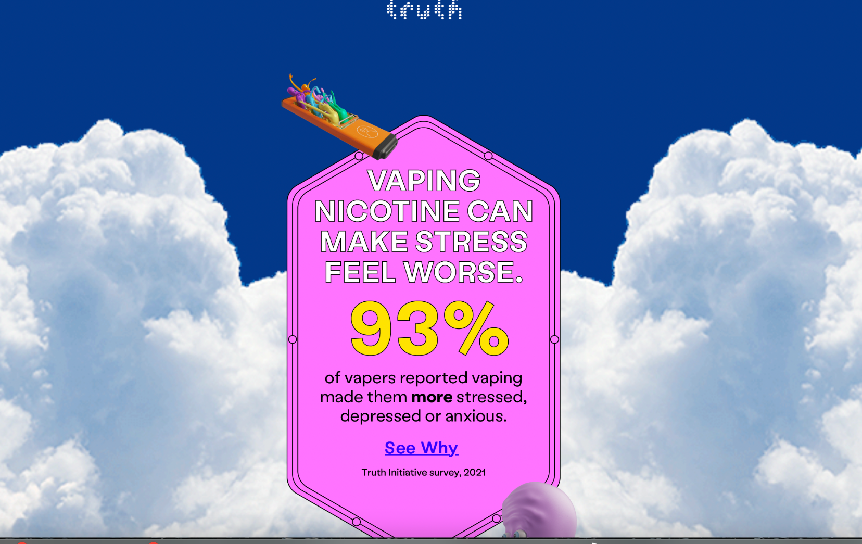
One feature that the site offers is hyperlinks, which are links to a site outside of the main web page. In Truth's instance their hyperlinks are embedded in the main page for users to click on to learn more information about a certain topic. Hyperlinks are important to user engagement because they keep the user in “control” of what they see, giving them a sense of autonomy while also giving a sense of never-ending information that the user can engage in. An example of the Truth implementing a hyperlink is on the first “page” of the site. When you first click on it, you are met with a statistic stating, “93% of vapers reported vaping made them more stressed, depressed or anxious.” This premise is laid on top of a bright pink background to grab the user’s attention. At the bottom, you see a “see why” bolded and underlined coaxing the user to click on it. When doing so, it brings you to a separate webpage which goes more into depth about the effects of vaping and what it can do with your stress levels, along with a video explaining why anxiety levels are so high in smokers. With hyperlinks like this there is an illusion of many possible outcomes. One never knows the exact results of one’s choices and it can feel as though the site has an infinite number of outcomes, which could result in users staying on the site for a longer period.
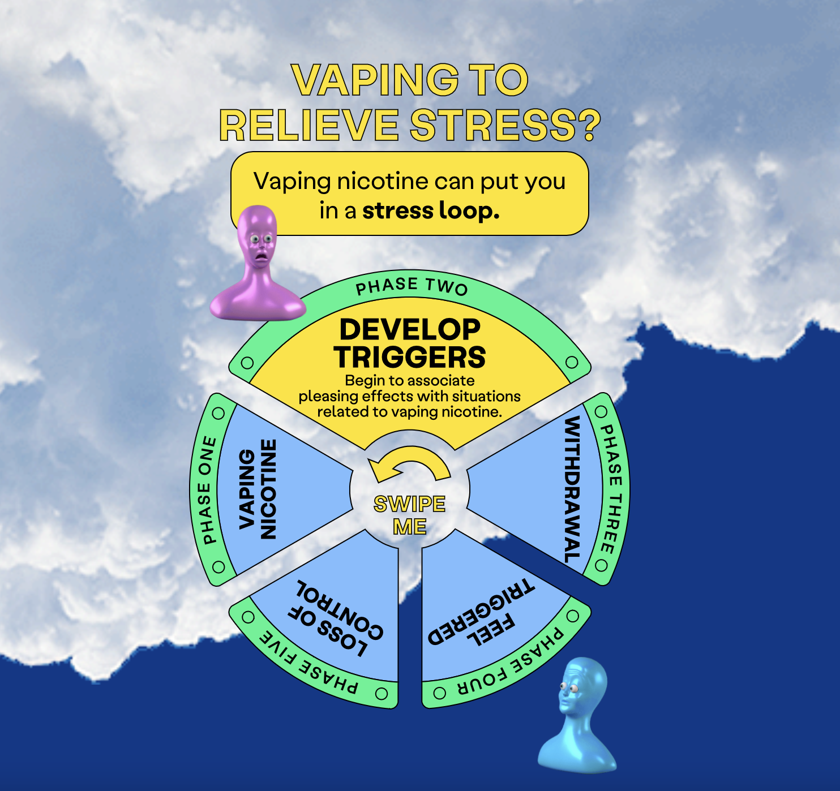
If you want to keep people on a site, some ways to do that is to create interactive games or graphics, where you must physically click on the graphic to see more or obtain more information. An example of this is an animated wheel that is meant to represent a “stress loop” a smoker might experience. There are four steps, so to understand what happens in the next step you must drag the mouse on the wheel, click on it, and the wheel swoops down to reveal what the next step is. However, the prompts are never-ending, being an interesting interactive tool that is also a symbol and representation of the “stress loop”. This tool helps the user understand smoking facts, but by making the user click and drag on the facts you are forcing them to become more engaged in the content, making sure they are following along with the facts instead of mindlessly scrolling.
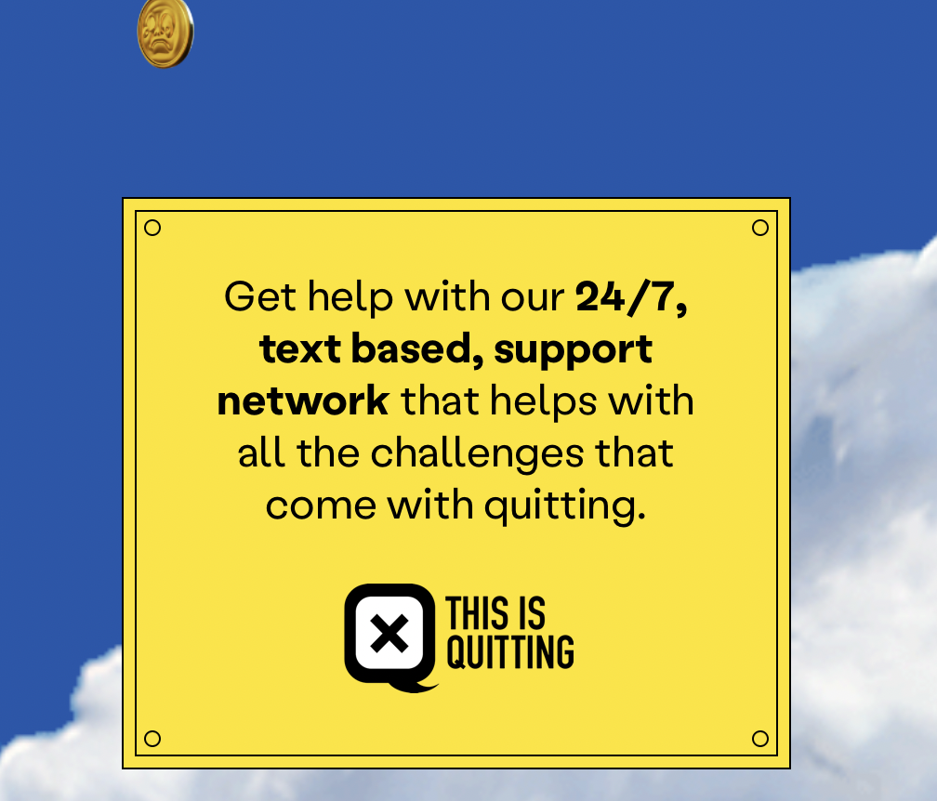
One thing people find joy in is connecting with other people. With that, a lot of people enjoy blogs and social media sites due to the human connection and relatability it offers. Interpersonal connection can boost a lot of users for a site. The Truth interactive site doesn’t have any blogs or chat rooms, but they do have an opportunity of interpersonal contact. When you are near the tail end of the site you are met with multiple prompts to “ditch your vape” by using their “24/7 text-based support” network that is meant to guide people to a vape free life. They ask for users’ number or for them to “subscribe” to their network, and by doing so people can opt in to get daily texts and advice from fellow quitters and experts. They also provide numerous information to reach out to counselors and mental health experts in case a person's mental health is on a serious decline. There is no immediate feedback like there would be if there was a chatroom, but by having a resource where a person can gain that connection is important for interactivity and engagement for that user, and possibly more returns to their site.
Truth campaigns have always been made by young adults to persuade their fellow youth to stop the cycle of vaping. Because of this, being able to relate to an audience is a key strategy to persuade them. Identification is a tool to use for persuasion, as it can connect the audience to the cause and create a sense of unity and togetherness. Although identification is usually used by political leaders to help them appeal to an audience, it is important to realize that this type of strategy can be used by anybody to persuade an audience. The Truth’s website seems to be appealing to a younger audience with not only its simple structure but also due to its youthful feel. One of the most obvious ways they connect to a younger audience is through the colorful color scheme throughout their site. Bright colors like yellow and pink make the content pop and “louder”, not only making it appealing to younger audiences but it also keeps their attention. Because of the amount of mediated content like social media and blogs everyone is trying to catch users’ attention and make them want to use their site, and that is what the Truth is doing with this color scheme.
The design is condensed into the middle of the screen, which was purposely done to be able to use the site on a phone screen. This helps with identifying with their audience since it is known that the younger generation are more likely to be doing activities or “googling” things on their phone. Along with the structure of the site, there is also a factor of simplicity to the design and information it gives. The information about vaping is reduced to a couple of sentences, which could be appealing to a younger audience and easier to digest for younger viewers.
Along with the design of the site the word choice is tailored to a younger audience. In one of their hyperlinked sites explaining the risks of vaping, they use informal language and talk “like a teenager”. For example, when explaining why vaping might cause more stress they say, “here’s the thing: If you smoke or vape, you’re probably going to tell us that it totally works as a stress reliever and we’re a bunch of idiots…”. This kind of language along with saying things like “ditch your vape” or “don’t let the vape companies get rich off of you,” feels like they are a friend telling you to stop vaping. This can help people feel like they are a part of a community, but also like they are not being talked down on. Being a part of a community, you will most likely want to do what they say to keep feeling that human connection. The Truth uses different techniques like art and language to make their audience feel like you are a part of their community, and not only that but a community where they are here to support your journey to quit vaping.
The Truth Breath of Stress Airs website is filled with interesting graphics, artwork, and important information to help the younger generation quit their habit of smoking. But all this hard work and intentional design features is all for nothing if it can’t persuade their audience to stop vaping. The design aspects are attention grabbing and would easily lure a teenager to look at what the site offers. A user could not only get stuck on the site but because of the simplicity and use of digestible language a younger person could obtain the facts about the harmful effects of vaping. One of the most persuasive aspects of the site is the “opt in text feature” that seems to be following you everywhere when scrolling on the site. It’s the “loudest” aspect of the design with its bright yellow background and requiring a simple amount of information to sign up for it. However, I believe the site needs to do better with their identification to their audience. This includes mostly adding more interpersonal communication opportunities and having more content where people can relate to. The younger generation is one of the most stressed generation, so this information is important for younger teenagers to read about, but by having better interpersonal communication and relatability more younger people will feel more apt to quit smoking.
Conclusion
The way people get their information, either by getting informed on the latest trend or understanding what's going on in the world, has become more digitized than ever. With the constantly changing internet, each generation will have a different experience with the world wide web each time it evolves. Meaning, the people who want to connect to that audience have to evolve too. The Breath of Stress Airs interactive website is Truth's attempt to connect with the younger generation in order to warn them about the dangers of smoking. Implementing many unique and eye grabbing content, they do this by crafting their digital world to reach out to the younger generation, and hopefully connect with them. Colorful content, funny graphics, and language choice all play a role in interacting with teenagers and young adults, along with interactive features and a chance to connect with support groups to help in the process to quit smoking. All of these elements combined will help persuade their target audience to convince them about the detrimental effects of smoking, and hopefully lure them in the right direction.
Like many of these campaigns in the past, The Truth initiative has been convincing teens to quit smoking for years, and hopefully with the development of more accessible content like this and a unique set up, connecting with the younger generation will be seen to be a success. That being said, digital spaces are constantly being evolved, meaning that digital rhetoric will possibly be used for analyzing future artifacts. It will be interesting to see what direction the internet might evolve into, and the process and changes people have to make to their content in order to satisfy and persuade the newest generation.

References
Buck (2022). Breath of stress air. Buck. https://buck.co/work/truth-breath-of-stress-air
Bright, R., & Henderson, A. (2008). Who is 42 Below? Language at work in the construction of organizational identity. Communication Journal of New Zealand, 9(1).
Campaign, S. P. W. (2022, March 17). Mojo Supermarket and Truth Initiative offer a Breath of Stress Air. PR Week. https://www.prweek.com/article/1749988/mojo-supermarket-truth-initiative-offer-breath-stress-air
Christina R.F., (2008). Aesthetics as weapons in the “war of ideas:” Exploring the digital and typographic in American conservative websites." Southern Communication Journal 73.2 (2008): 122-142.
Corr. A., (2024, July 3). Vaping is a “Breath of stress Air” in Campaign for Truth Initiative. Muse by Clios https://musebyclios.com/health/vaping-breath-stress-air-campaign-truth-initiative/
Edrington, C. L. (2021). Information, identification, or both? A rhetorical analysis of how BLM uses their official website. The Pennsylvania Communication Annual, 77(2), 11. https://scholarcommons.sc.edu/cgi/viewcontent.cgi?article=1002&context=jour_facpubs
Endaltseva, A., & Mordvinova, M. (2015). Health communication and rhetorical challenges for the anti-smoking policy in Russia. Journal of Communication in Healthcare, 8(4), 325–334. https://doi.org/10.1179/1753807615Y.0000000021
Eyman, D. (2015). Digital rhetoric: Theory, method, practice. University of Michigan Press. http://library.oapen.org/handle/20.500.12657/24037
Eyman. D., (Nov. 22, 2016). Looking back and looking forward: Digital rhetoric as evolving field. enculturation. https://enculturation.net/looking-back-and-looking-forward
FDA (2024, Sept 5). Results from the annual national youth tobacco survey. United States Food and Drug Administation. https://www.fda.gov/tobacco-products/youth-and-tobacco/results-annual-national-youth-tobacco-survey
Hoffman, E. W. (2016). Improving the future by looking to the past: An examination of Florida’s “Truth” anti-smoking campaign. Florida Communication Journal, 44(1), 49–59.
Kuypers, J. A. (2009). Rhetorical criticism: perspectives in action. Lexington Books. Ch.16. http://ci.nii.ac.jp/ncid/BB02373393
Dueffert, N. (n.d.). Truth initiative. Mayo Clinic. https://ce.mayo.edu/content/truth-initiative
Molek-Kozakowska, K. (2020). Graphic emotion: a critical rhetorical analysis of online children-related charity communication in Poland. Critical Discourse Studies, 17(1), 72–90. https://doi.org/10.1080/17405904.2019.1567362
NCESD (2023, June 12). The truth – it’s a breath of stress air. NCESD. https://www.ncesd.org/behavior-health/breath-of-stress-air/
NIDA. (2020, Jan 8) Vaping devices (Electronic Cigarettes) drugFacts. NIDA https://nida.nih.gov/publications/drugfacts/vaping-devices-electronic-cigarettes
PR Newswire USA (2014, Aug 25) The End Of Tobacco? - truth® rallies teens to harness their online influence to become the first smoke-free generation proven-effective youth smoking prevention campaign launches new chapter, challenges teens to - "Finish It". NewsBankinc.
Quesenberry, L., Garland, B., & Sykes, B. (2006). Persuasive Design Elements for E-Tail Art Galleries: A Content Analysis. Marketing Management Journal, 16(2), 81–93.
Targeted News Service (USA). (Sept 7, 2024). Truth initiative: Significant drop in youth E-Cigarette use marks progress, but nearly 40% of teens who vape frequently remain at high risk for nicotine addiction, a serious public health concern. NewsBankinc.
truth initiative (2022, March 11). Breath of stress air is calling what a vape truly is. truth initiative.https://truthinitiative.org/research-resources/emerging-tobacco-products/breath-stress-air-calling-vape-what-it-truly
truth initiative (n.d). Our history. truth initiative. https://truthinitiative.org/who-we-are/our-history
truth initiative (n.d). Youth smoking and vaping prevention. truth initiative. https://truthinitiative.org/what-we-do/youth-smoking-prevention-education
William L. Benoit & Allison Harthcock (1999) Attacking the tobacco industry: A rhetorical analysis of advertisements by the campaign for tobacco‐free kids. Southern Journal of Communication. 65(1), 66-81. DOI:10.1080/10417949909373156
Winter, E. A. (2021). Beckoning “boss Babes:” examining Mary Kay’s online recruitment rhetoric. Ohio Communication Journal, 59, 49-63. https://www.ohiocomm.org/wp-content/uploads/2021/06/OCJ-2021-FullVolume.pdf#page=56

Zhang, M. (2022, August 16). The rise and fall of e-cigarettes. The Epoch Times. https://www.theepochtimes.com/health/the-rise-and-fall-of-e-cigarettes-4651324?utm_medium=GoogleAds&utm_source=PerfmaxM&utm_campaign=PM_max_BOAoutage_Test22a_20241003&gclid=EAIaIQobChMItprUpNSOiQMVTGJHAR3GvzFvEAAYASAAEgLjT_D_BwE

US Staff, C. (2022, March 18). Mojo Supermarket and Truth Initiative offer a ‘Breath of Stress Air’. Medical Marketing & Media (USA). https://infoweb-newsbank-com.eu1.proxy.openathens.net/apps/news/document-view?p=AWNB&docref=news/188D5B0A07BD4AF0.
PR Newswire (March, 2022) truth® debunks the myth that vaping nicotine relieves stress - Breath of Stress Air underscores connection between vaping nicotine and mental health and encourages young people to trade stress air for fresh air by quitting vaping. NewsBank: Access World News. https://infoweb-newsbank-com.eu1.proxy.openathens.net/apps/news/document-view?p=AWNB&docref=news/188ADA9A6ECE9310
Nielsen, A. E. (2002). Rhetorical features of the company website. Centre for Internet Research.https://www.researchgate.net/profile/Anne-Ellerup-Nielsen/publication/40236516_Rhetorical_Features_of_the_Company_Website/links/09e41507dc28ba5958000000/Rhetorical-Features-of-the-Company-Website.pdf
Baab, L. M. (2008). Portraits of the Future Church: A Rhetorical Analysis of Congregational Websites. Journal of Communication & Religion, 31(2), 143–181. https://doi.org/10.5840/jcr20083126

